From Shaw to Shaping the Future of Genomics, Dr. Tshaka Cunningham Carves a Path for Black People in Science
by Stacy M. BrownAugust 28, 2024
- Click to share on Facebook (Opens in new window)
- Click to share on Twitter (Opens in new window)
- Click to share on LinkedIn (Opens in new window)
- Click to email a link to a friend (Opens in new window)

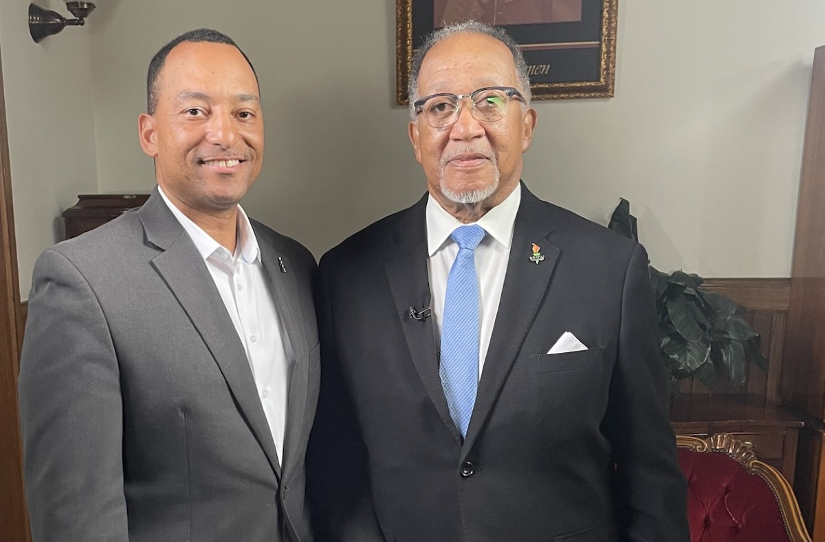Dr. Tshaka Cunningham (left) appeared on the PBS show "The Chavis Chronicles," hosted by Dr. Benjamin F. Chavis (right). (Courtesy photo)


Sign up to stay connected
Get the top stories of the day around the DMV.

- WIN DailyStart your weekdays right with the most recent stories from the Washington Informer website. Once a day Monday-Friday.
- JPMorganChase Money TalkPresented with JPMorganChase, this financial education series is dedicated to bridging the racial wealth gap. Let's embark on a journey of healthy financial conversations together. Bi-Monthly.
- Our House D.C.Dive deep into our monthly exploration of the challenges and rewards of Black homeownership. Monthly.
- Deals & OffersExclusive perks, updates, and events from The Washington Informer partners just for you.
- Word in Black NewsletterOur national news platform provides reporting, op-eds and solutions on our communities' most pressing issues six days a week.
SIGN UP

Dr. Tshaka Cunningham, a pioneering molecular biologist, has made an extraordinary journey from the Shaw neighborhood of Washington, D.C. to the cutting edge of precision medicine and genomics.
Returning to his roots for an interview on the PBS show “The Chavis Chronicles,” Cunningham shared insights into his career, the importance of diversity in science, and his commitment to advancing genomics for the betterment of all communities.
Raised in D.C.’s historic Shaw area, Dr. Cunningham’s early exposure to science came from a deeply personal source—his grandmother, a cancer researcher who played a pivotal role in sparking his lifelong passion for molecular biology.
“I was exposed to science at an early age from my grandmother, a cancer researcher,” Cunningham said before his 30-minute discussion with National Newspaper Publishers Association (NNPA) President and CEO Dr. Benjamin F. Chavis Jr., the host of “The Chavis Chronicles.” “She sparked in me that intellectual curiosity of what caused a cancer cell to be a cancer cell. It’s fascinating to me.”
This fascination led Cunningham to pursue a career in molecular biology, a field that explores the fundamental building blocks of life.

Sign up to stay connected
Get the top stories of the day around the DMV.

- WIN DailyStart your weekdays right with the most recent stories from the Washington Informer website. Once a day Monday-Friday.
- JPMorganChase Money TalkPresented with JPMorganChase, this financial education series is dedicated to bridging the racial wealth gap. Let's embark on a journey of healthy financial conversations together. Bi-Monthly.
- Our House D.C.Dive deep into our monthly exploration of the challenges and rewards of Black homeownership. Monthly.
- Deals & OffersExclusive perks, updates, and events from The Washington Informer partners just for you.
- WIN AfricaUplifting Voices in the African Diaspora that Uplift the World.
- Word in Black NewsletterOur national news platform provides reporting, op-eds and solutions on our communities' most pressing issues six days a week.
SIGN UP

“The reason I became a molecular biologist is because the sum total of the organism that we are is a collection of molecules that know how to beautifully orchestrate the symphony that is life,” he explained.
A relentless curiosity and a desire to comprehend life at its most fundamental level led him from Princeton University, where he received his bachelor’s degree, to Rockefeller University for his PhD, and postdoctoral training at the Pasteur Institute in Paris and the National Institutes of Health in Bethesda.
But Cunningham’s journey was not just about academic achievements; it was also about overcoming the social challenges of being a “cool nerd” in a community where academic excellence wasn’t always celebrated.
“I liked playing sports and chasing girls,” Cunningham admits with a smile. “But I remember growing up here in D.C., it wasn’t cool to be smart back in the day, so I used to have to lie about my grades. But we have to make it cool to be a nerd and get good grades.”

Cunningham’s Work to Benefit All Through Science
Significant contributions to science and society have been a hallmark of his career.
At the Department of Veterans Affairs (VA), Cunningham played a critical role in overseeing national research programs in aging and neurodegenerative diseases. He also spearheaded initiatives to ensure minority veterans were well-represented in the VA’s Million Veteran Program, emphasizing the importance of diversity in genomic research.
Motivated by a commitment to making precision medicine more inclusive, Cunningham co-founded the Faith-Based Genetic Research Institute, a nonprofit organization dedicated to improving lives through genomics.
His belief in the potential of science to benefit all communities is unwavering.
“More of our people should be involved in science,” he said. “It takes a level of curiosity, tenacity, and resourcefulness to be a scientist. They call it research for a reason because you have to search and research and constantly fail in the lab. Our people are good at being resourceful and tenacious, and that’s what it takes to be scientists.”
As the co-founder and chief scientific officer of Polaris Genomics and TruGenomix Health, Cunningham is at the forefront of using genomics to tackle some of the most pressing health challenges, including PTSD.
He emphasized the importance of understanding diseases at the molecular level to develop effective treatments.
“Some cancers we are getting there, and some we can cure,” Cunningham noted. “In the next 20-25 years, that percentage will go up. Prevention helps us cure, but we have to understand at the molecular level what causes the disease, and that’s what people like me do; molecular biologists and researchers continue to do.”
His peers said Cunningham’s journey from Shaw to shaping the future of genomics is a testament to the power of curiosity, determination, and the pursuit of knowledge.
Cunningham’s work is not just about advancing science; it’s about breaking down barriers and ensuring that genomics benefits are accessible to all communities.
“Not only as it pertains to communities of color but all humanity; these myths and stereotypes that are out here are from white supremacists, and they are not based on truth and facts,” Chavis stated. “Science is based on truth and facts. If our nation was better informed, we would not be so divisive.”

